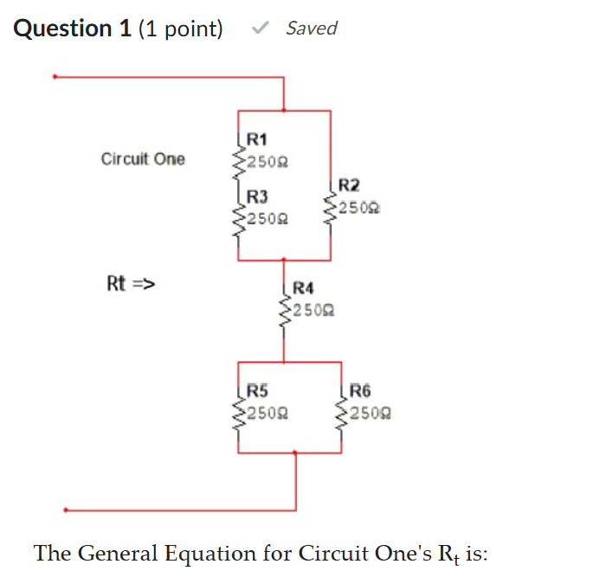

The General Equation for Circuit One's R_{t} is:
Question 1 options:
R_{t} = (R1 + R3) // R2 + R4 + R5 + R6
R_{t} = R1 // R2 + R3 + [R4 // (R5 + R6)]
R_{t} = R1 // (R2 + R3) + R4 // R5 // R6
R_{t} = (R1 + R3) // R2 + R4 + R5 // R6

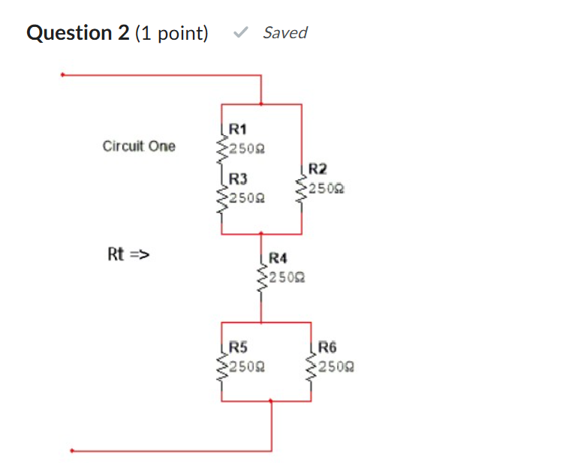
The calculated value for Circuit One's R_{t} is:
Question 2 options:
442 Ω
325 Ω
542 Ω
375 Ω

Open in Multisim and measure the value of R_{t}. You should discover that the calculated value from the previous question and the measured values of R_{t} differ. Which of the following statements best describe your findings:
Question 3 options:
R_{t} (measured) = 500 Ω
R1(measured) = 0 Ω (because R1 is shorted)
R_{t} (measured) = 500 Ω
R3 (measured) = 0 Ω (because R3 is shorted)
R_{t} (measured) = 500 Ω
R4 (measured) = 0 Ω (because R4 is shorted)
R_{t} (measured) = 542 Ω
No faulty component in circuit

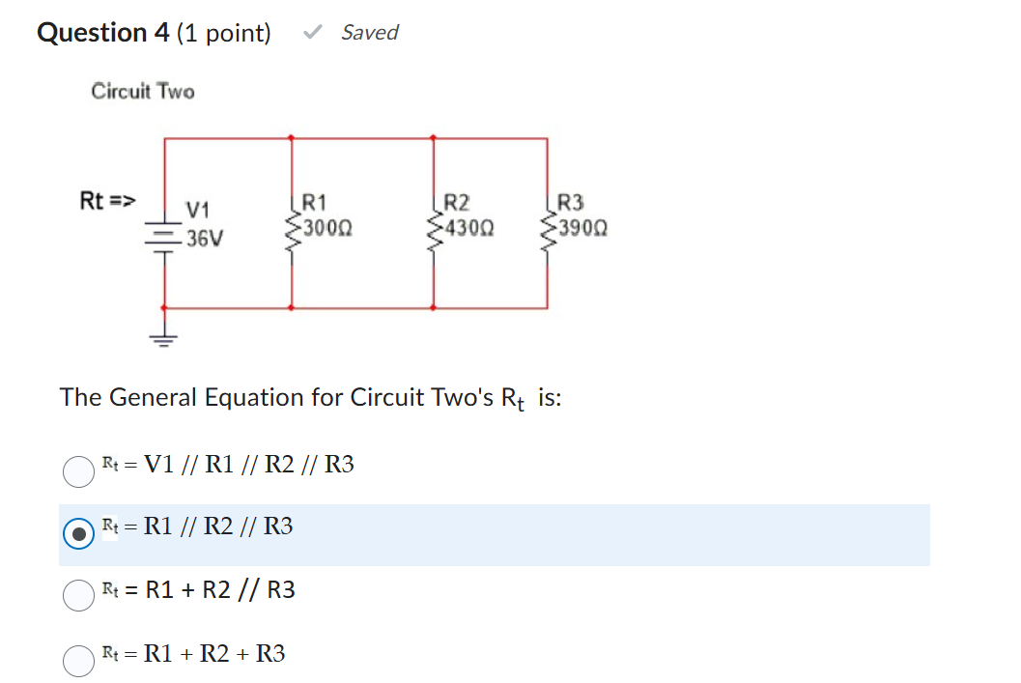

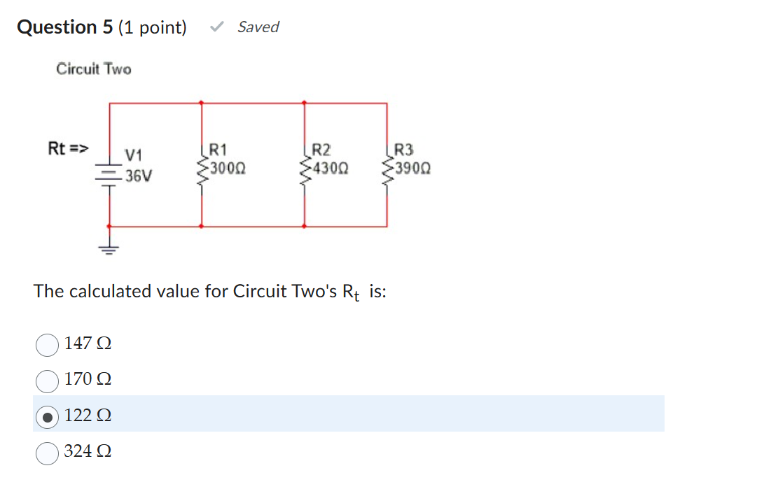

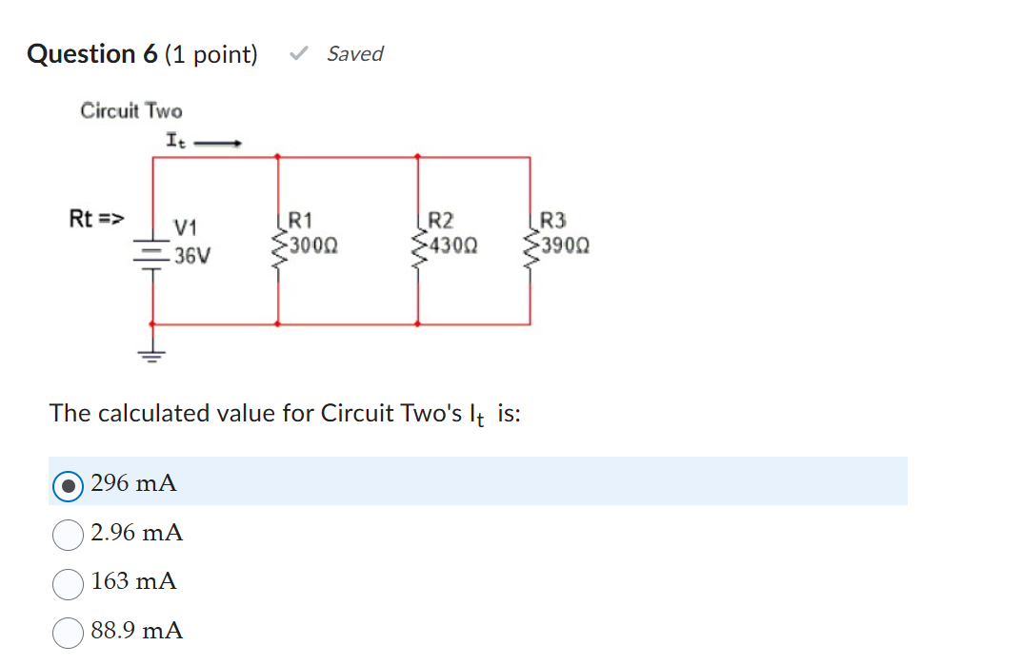

Open in Multisim and measure the value of It. You should discover that the calculated value from the previous question and the measured values of I_{t} differ. Which of the following statements best describe your findings:
Question 7 options:
I_{t} (measured) = 296 mA
No faulty component in circuit
I_{t} (measured) = 212 mA
R2 (measured) = ∞ (because R2 is open)
I_{t} (measured) = 212 mA
R3 (measured) = ∞ (because R3 is open)
I_{t} (measured) = 212 mA
R1 (measured) = ∞ (because R1 is open)

